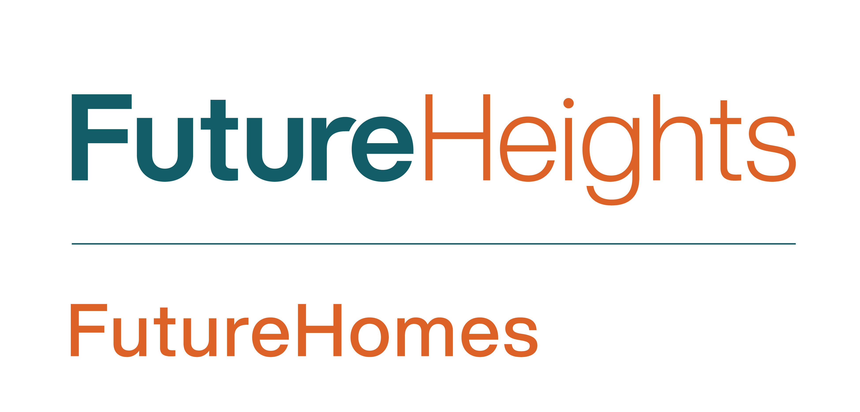
FutureHomes Model Block Grant Program
About FutureHeights:
FutureHeights is a nonprofit community development organization working to ensure a vibrant and sustainable future for Cleveland Heights and University Heights. We work as change agents by inspiring and facilitating communication, collaboration, engagement and empowerment among our residents, businesses, other community-based organizations and local government.

The Goals of the FutureHomes Model Block Grant Program:
FutureHeights seeks to preserve the distinctive features of the older homes that are abundant in our neighborhoods. These homes exhibit a variety of architectural styles and details not commonly seen in other communities. They represent the times in which they were built, our history, and are a big part of what makes Cleveland Heights unique.
The FutureHomes program focuses on facilitating the rehabilitation of distressed homes with our rehab partners, particularly in target neighborhoods that have experienced recent disinvestment. In addition, FutureHeights has outlined the area surrounding the city’s newly renovated high school as a Model Block area, in which to focus resources from a number of initiatives in order to make physical improvements aimed at restoring neighborhood pride and improving property values and quality of life.
Grant Guidelines:
- FutureHeights awards grants of up to $500 to homeowners for exterior improvements, such as paint, porch repair, or landscaping, to owner-occupied homes in its designated Model Block area.
- Projects must repair or maintain character-defining features of the house or make improvements to landscaping that is visible from the street.
- Grant recipients are not required to match the amount of the grant.
- Grant duration is up to one year.
- Grant dollars are issued on a reimbursement basis. FutureHeights will hold the money, and recipients will submit expenses with receipts and a project report for reimbursement.
- The FutureHeights FutureHomes Committee will make grant decisions.
- Grant applications are accepted on a rolling basis until funding for that year has been exhausted.
- For more information, call the FutureHeights office at 216-320-1423 or send an e-mail to alawless@futureheights.org.

Submit Completed Applications to:

Email: alawless@futureheights.org
Subject: FutureHomes Model Block Grant Program

Mail: FutureHeights
Attn: FutureHomes Model Block Grant Program
2843 Washington Blvd. #105
Cleveland Heights, OH 44118

FutureHomes Model Block Grant Application
GRANT APPLICATION AND BUDGET FORM
Please complete the application and budget form as thoroughly as possible.
Type or print your responses clearly.
HOMEOWNER INFORMATION

Homeowner name: Click or tap here to enter text.

Home address: Click or tap here to enter text. Zip: Click or tap here to enter text.

Phone number: Click or tap here to enter text. E-mail: Click or tap here to enter text.

Please indicate the exact address (or nearest address) where your project will take place:
Click or tap here to enter text.

Total request from the FutureHomes Model Block Grant Program (Up to $500): $____________
Total project budget: $____________

Has your organization applied for other grants for this project ☐ Yes☐ No
If “yes”, please name the organization where you applied for funding and the amount?
- Applied to: _____________________________________________________________ _________
Amount: $____________ Were you Funded? ☐Yes ☐No ☐Pending

The signatory declares that any funds received as a result of this application will be used only for the purposes set forth within, and that information presented in this application is accurate.

Should grant funds be awarded, the signatory agrees to post a FutureHomes Program sign in the property’s front yard during the completion of the project.

The signatory also consents to be interviewed for an article in the Heights Observer, a community-journalism publication produced by FutureHeights.

Name (Typing your name below serves as an electronic signature on this document)

___________________________________________________________________________________ _

ABOUT THE HOMEOWNER
Tell us about yourself. How long have you lived at this address? What would completing this project mean to you and your family?

DESCRIBE YOUR PROJECT
What issue does your project address? (Check all that apply)

☐Front Porch Repair
☐Landscaping
☐Painting
☐Front stair/walkway repair
☐Roof Repair
☐Other ____________

Describe the project. What do you want to do? Why do you want to do it? How will grant funds be used?

WORK PLAN
Please list all major steps to make your project happen.
Activity/ Task List | Start/End Dates
Click or tap here to enter text. | Click or tap here to enter text.
Click or tap here to enter text. | Click or tap here to enter text.
Click or tap here to enter text. | Click or tap here to enter text.
Click or tap here to enter text. | Click or tap here to enter text.
Click or tap here to enter text. | Click or tap here to enter text.
Click or tap here to enter text. | Click or tap here to enter text.
Click or tap here to enter text. | Click or tap here to enter text.
Click or tap here to enter text. | Click or tap here to enter text.
Click or tap here to enter text. | Click or tap here to enter text.
Click or tap here to enter text. | Click or tap here to enter text.

PROJECT IMPACT
Please explain how the project will make a visible impact on the neighborhood: restore neighborhood pride, improve neighborhood property values, or increase neighborhood quality of life.

THE BUDGET
The budget table displays two categories: supplies/materials and services. List each item in the appropriate space. Use another sheet of paper if you need more lines. Donated in-kind professional services should be listed at market value. Other volunteer services, such as clerical or manual labor, should be listed at $12.00 per hour. If you applied for another grant from another source for this project but don’t know if you’ve received it yet, please write “pending” next to the listing.
Description of Item | Total Cost | FH Mini-Grant $ | Neighborhood Match $ | Neighborhood Match In-Kind
Supplies and Materials (list)
Enter text | Enter text | Enter text | Enter text | Enter text
Enter text | Enter text | Enter text | Enter text | Enter text
Enter text | Enter text | Enter text | Enter text | Enter text
Enter text | Enter text | Enter text | Enter text | Enter text
Enter text | Enter text | Enter text | Enter text | Enter text
Enter text | Enter text | Enter text | Enter text | Enter text
Services (list)
Enter text | Enter text | Enter text | Enter text | Enter text
Enter text | Enter text | Enter text | Enter text | Enter text
Enter text | Enter text | Enter text | Enter text | Enter text
Enter text | Enter text | Enter text | Enter text | Enter text
Enter text | Enter text | Enter text | Enter text | Enter text
Enter text | Enter text | Enter text | Enter text | Enter text
Enter text | Enter text | Enter text | Enter text | Enter text
Enter text | Enter text | Enter text | Enter text | Enter text
Total Project Budget | Enter text | Enter text | Enter text | Enter text

BUDGET NARRATIVE WORKSHEET
Briefly describe the details of your project expenses to be paid for with the FutureHomes Model Block Program Mini Grant. Please include price quotations for equipment and supplies, and quotes for contract services. Use an additional page if necessary.

